

Digital Technology – Unit Plan Westland High School

Python Programming
In technology, students learn to be innovative developers of products and systems and discerning consumers who will make a difference in the world.
Kaua e rangiruatia te hāpai o te hoe; e kore tō tātou waka e ū ki uta.
Do not lift the paddle out of unison; our canoe will never reach the shore.
AIM(S) OF UNIT: | Year Groups:
This unit aims to ensure that students learn Python programming and develop critical thinking, problem-solving, and project management skills that are essential for their future academic and professional endeavours. These aims cover a broad range of skills and concepts, ensuring students develop a strong foundation in Python programming.  - Introduction to Python and Programming Concepts  - Introduction to Object-Oriented Programming (OOP)  - Variables, Data Types, and Operators  - Control Structures: Conditionals and Loops  - Data Structures: Lists, Tuples, and Dictionaries  Error Handling and Debugging | Middle School  Main focus: Year 11/12/13

School Values
Whanaungatanga  - Actively building and contributing to positive connections with others.  Within this unit, students are actively encouraged to share their learning with their peers. They are encouraged to work together to better understand the concepts. | Rangatiratanga  - Develop leadership with confidence, respect, self-determination and teamwork.  This unit helps build the student's confidence in completing tasks that can be frustrating and challenging at times. Students are encouraged to engage in peer discussions, where they can share their learnings to help solidify their understanding.
Manaakitanga  - Manaakitanga – Uplifting and empowering ourselves and others. | Kaitiakitanga  - Promoting guardianship and preservation of the school values, learning and the environment.

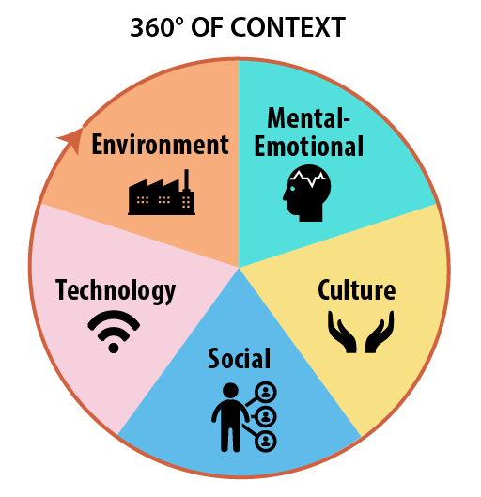Contexts of Learning
Environment | Student will be able to use either the Windows machines or their Chromebooks. They will have access to both software specific to the Windows environment and online applications, where they can complete their work on their Chromebooks.
Mental-Emotional | I will be using the Check-in Diary strategy to support students in feeling more comfortable asking more in-depth questions, and I will be keeping notes. I will make changes or adjustments to the course as students become more comfortable with their work. This enables Student Voice to be an integral part of the planning and delivery of the course.
Culture | Students can negotiate to complete any activities in their first language. Programming is not English-centric. Students can also adjust any of the set problem activities to suit their specific learning sphere.
Social | Students are encouraged to support each other in learning the language by sharing what they have learnt and to be acknowledged for their successes. In the case of learning programming, it is essential to celebrate the small wins.
Technology | Students will be able to use their Chromebooks and/or Windows Desktops for this course.
Local Curriculum Links |  | Mātauranga Māori
Some of the activities are context into the New Zealand and Pacific-specific settings |  | Introduce the concept of Mātāpono Māori https://www.csfieldguide.org.nz/en/chapters/human-computer-interaction/m%C4%81t%C4%81pono-m%C4%81ori/

Skills
Literacy:  Structured Literacy | Students will need to read and interpret the activity task. They will need to read and interpret flowcharts. They will need to read and interpret pseudocode.  - Coding syntax is very exact, so Proofreading is a highly focused task.  - Opportunities for rich text, via provided notes and CodeAvengers, allow the information to be expressed in multiple ways, helping students understand the concepts.  - Discuss the Etymology, especially linking the concepts to mathematics concepts.
Numeracy: | Students will need to code fundamental mathematical problems into activity tasks.
Digital Tech: | This unit requires an Internet browser, allowing it to be completed on a Chromebook.  Students will be covering:  - File Management  - Cyber-security  - Ethical practice
Practical: | Students will need to take a basic set of notes that I write on the whiteboard. They will also need to be able to draw flowcharts by hand. Both activities are set at the student's pace of work.  Practical activities for programming in Python are delivered and completed using different methods, including CodeAvengers, Replit, and Visual Studio Code. Students are taught that they can also write pseudocode or draw flowcharts by hand.

Health & Safety - Link
Computing Room
Safety Issues | This unit covers the ethics of computer use, and we cover the security of data.  Students feeling safe to discuss ideas is further developed from the training in the previous units.

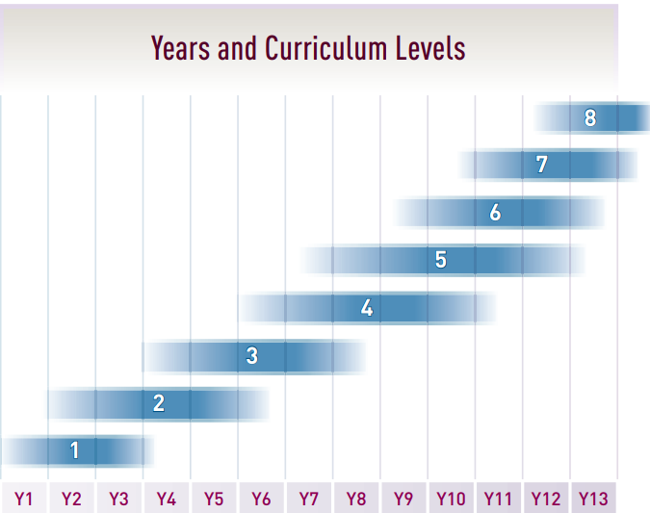 |  |  | New Zealand Curriculum Achievement Objectives  Link
 |  | LEVEL 4 | LEVEL 5 | LEVEL 6
Technological Practice |  | Undertake planning that includes reviewing the effectiveness of past actions and resourcing, exploring implications for future actions and resource allocation, and considering stakeholder feedback to enable the development of an outcome. | Analyse their own and others’ planning practices to inform the selection and use of planning tools. Use these to support and justify planning decisions (including those related to resource management) that will lead to the development of an outcome through to completion. | Critically analyse their own and other’s past and current planning practices to make an informed selection and effective use of planning tools. Use these to support and justify ongoing planning that will lead to the development of an outcome through to its completion.
 | Planning for practice
 | Brief development | Justify the nature of an intended outcome concerning the need or opportunity. Describe the key attributes identified in stakeholder feedback, which will inform the development of an outcome and its evaluation. | Justify the nature of an intended outcome concerning the need or opportunity. Describe specifications that reflect key stakeholder feedback and that will inform the development of an outcome and its evaluation. | Justify the nature of the intended outcome in terms of the need or opportunity, and justify the specifications in relation to key stakeholder feedback and broader community considerations.
 | Outcome development and evaluation | Investigate a context to develop ideas for feasible outcomes. Undertake functional modelling that takes account of stakeholder feedback to select and create the outcome that best addresses the key attributes. Incorporating stakeholder feedback, evaluate the outcome’s fitness for purpose in terms of how well it addresses the need or opportunity. | Analyse their own and others’ outcomes to inform the development of ideas for feasible outcomes. Undertake ongoing functional modelling and evaluation that takes account of key stakeholder feedback and trialling in the physical and social environments. Use the information gained to select and develop the outcome that best addresses the specifications. Evaluate the outcome’s fitness for purpose against the brief. | Critically analyse their own and others’ outcomes to inform the development of ideas for feasible outcomes. Undertake ongoing experimentation and functional modelling, taking account of stakeholder feedback and trialling in the physical and social environments. Use the information gained to select, justify, and develop an outcome. Evaluate this outcome’s fitness for purpose against the brief and justify the evaluation using feedback from stakeholders.
Technological Knowledge |  | Understand how different forms of functional modelling are used to explore possibilities and justify decision-making and how prototyping can be used to justify the refinement of technological outcomes. | Understand how evidence, reasoning, and decision-making in functional modelling contribute to the development of design concepts and how prototyping can be used to justify ongoing refinement of outcomes. | Understand the role and nature of evidence and reasoning when managing risk through technological modelling.
 | Technological modelling
 | Technological products | Understand that materials can be formed, manipulated, and/or transformed to enhance fitness for a technological product. | Understand how materials are selected based on desired performance criteria. | Understand how materials are formed, manipulated, and transformed in different ways, depending on their properties, and understand the role of material evaluation in determining suitability for use in product development.
 | Technological systems | Understand how technological systems employ control to allow for the transformation of inputs into outputs. | Understand the properties of subsystems within technological systems. | Understand the implications of subsystems for the design, development, and maintenance of technological systems.
Nature of Technology |  | Understand how technological development expands human possibilities and how technology draws on knowledge from a wide range of disciplines. | Understand how people’s perceptions and acceptance of technology impact technological developments and how and why technological knowledge becomes codified. | Understand the interdisciplinary nature of technology and its implications for maximising possibilities through collaborative practice.
 | Characteristics of technology
 | Characteristics of technological outcomes | Understand that technological outcomes can be interpreted in terms of how they might be used and by whom and that each has a proper function as well as possible alternative functions. | Understand that technological outcomes are fit for purpose in terms of time and context. Understand the concept of malfunction and how “failure” can inform future outcomes. | Understand that some technological outcomes can be perceived as both product and system. Understand how these outcomes impact other outcomes and practices and on people’s views of themselves and possible futures.

Slideshow
Juniors | Binary | Slides 2 to 7  What is Programming?  Work through the Binary Unit
Middle/Seniors  1/2 | Variables  Setup Code Avengers | Slides 15 to 18  Slides 19 to 22  Work through Python 1 or NCEA Python 1 tutorials
3 | Flowcharts and Pseudocode  Setup Code Avengers IDE | Slides 8 to 13  Work through Slides 23 to 28
4 | Problems outside the tutorial set.  Replit Introduction  Code Runner Intro | Slides 23 to 28  Work through Slides 36 to 40  Slide 77  Aimed at the Code Avengers Top 10 students
5 | CodeAvengers Catchup | Code Avengers Lessons 1 to 10 |  | Formative Assessment - Code Runner released to students.
6 | Programming - IF/ELSE | CodeAvengers Lessons 11 to 20  Slides 51 to 61  Students asked if they could do their assessment in Visual Studio Code - setup instructions are on Slide 78 |  | The Summative Assessment has been released to students.  - Cover sheet  - Assessment Instructions  - Assessment Schedule  - Output Example
7 | Programming - Loops | CodeAvengers Lessons 21 to 30  Slides 63 to 75 |  | Middle School - Assessment is CodeAvengers Progress Report.
8 | Assessment Clarity  Last week, we confirmed that students understand what is required to meet the assessment criteria. | Slides 79 to 87  Check that students can access the XBOX Game Bar for recording purposes.
9 | Assessment Time  Introduce Usability | Students are to continue working through their assessment.  Take a moment to discuss the usability of the student's assessment interface. It is not one of the criteria. However, an Excellence student may want to tweak the interface. It is also a place for students to move as they hand in their assessment work. |  | Assessment due
10 | Set students up for the next term unit - Process and Outcomes. | Some students are interested in completing their projects in a programming format, which will allow them to continue learning from the work in this unit.

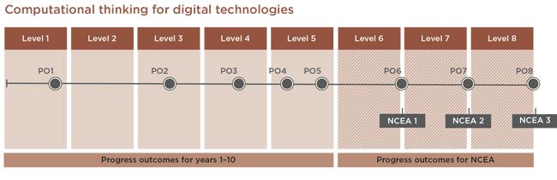 |  |  | Reporting & Assessment Link
SLOs
- Computational Thinking - Coding
Year 11 | PO6 | In authentic contexts, taking into account end-users, students determine and compare the computational complexity of two iterative algorithms for the same problem size. They understand the concept of compression coding for different media types, its typical uses, and how it enables widely used technologies to function.  Students use an iterative process to design, develop, document and test basic computer programs. They apply design principles and usability heuristics to their designs and evaluate user interfaces in terms of them.
Middle School | PO4 | In authentic contexts and considering end-users, students decompose problems to create simple algorithms using the three fundamental building blocks of programming: sequence, selection, and iteration. They implement these algorithms by creating programs that use inputs, outputs, sequence, basic selection using comparative operators, and iteration. They debug simple algorithms and programs by identifying when things go wrong with their instructions and correcting them, and they can explain why things went wrong and how they fixed them.  Students understand that digital devices represent data using binary digits and have methods for detecting errors in data storage and transmission. They evaluate the efficiency of algorithms, recognising that computers need to search and sort large amounts of data. They also evaluate user interfaces in terms of their efficiency and usability.
 | PO5 | In authentic contexts and considering end-users, students independently decompose problems into algorithms. They use these algorithms to create programs with inputs, outputs, sequences, and selections that utilise comparative and logical operators, variables of different data types, and iterations. They determine when to use other types of control structures.  Students document their programs using an organised approach for testing and debugging. They understand how computers store more complex types of data using binary digits, and they develop programs considering human-computer interaction (HCI) heuristics.

- Middle School  - Level 1 - 92004  - Level 2 - 91896  - Level 3 - 91906 | ACHIEVED | Create a computer program | Cover Sheet  Assessment Instructions  Output Example  Assessment Marking Schedule  Submission Slideshow
 | MERIT | Create a well-structured computer program.
 | EXCELLENCE | Create a flexible and robust computer program.
Students are introduced to programming using binary and Python.  Students become familiar with the structure of a program.  Students can show an understanding of the specific syntax requirements for Python. | - use a suitable programming language to construct a program that performs the task  - written a computer program that can:  - store at least two types of data in variables  - take input from a user, sensor, or another external source  - produce output based on the program control flow  - use sequence, selection, and iteration control structures  - use data stored in a collection. |  | Slides 2 to 13  CodeAvengers
Students can undertake a process for testing and debugging their programs. | - test and debug the program, showing that it works on expected cases  - included documentation that shows the program functions and has been debugged in response to testing against expected values. Documentation shows (or a video explains) the test cases for each test, the test results, and the changes made to the program based on the testing. While broadly functional, the program may contain minor errors (for example, it might skip the first or last question).  - Test and debug the program to ensure it works on expected and boundary cases.  - Included documentation of testing that shows that the program has been debugged, works well, and produces accurate output even at boundaries. For example, if a ranking system of “poor, okay, good, great” is used for a user’s final score, these ranks are applied accurately at score boundaries. Documentation shows (or a video explains) the test cases for each test, the test results, and the changes made to the program based on the testing.  - Test and debug the program to ensure it works as expected on boundary cases and with invalid input.  - Included documentation of testing that shows that the program has been debugged, works well, and produces accurate output even when the user enters unexpected or invalid data. For example, testing evidence shows the program can recognise when an incorrect data type is entered and help the user correct their mistake. Documentation shows (or a video explains) the test cases for each test, the test results, and the changes made to the program based on the testing. |  | Slides 82 to 84  CodeRunner
 | - Document the program with comments.  - Written code that includes some comments.  - Document the program with comments that clarify the purpose of code sections, including comments on sections of code that explain the purpose of the code rather than just translating each line. For example, a comment might describe a section of code that deals with collecting and sanitising input rather than rephrasing single lines of code. |  | Slides 18 and 81  CodeAvengers
 | - Written a computer program that works as a quiz that asks the user a series of questions about a performer, movie, or television show from Aotearoa, New Zealand or the Pacific region and determines if their answers are correct. The program may provide the user with feedback on their answers and track their score. |  | Problems on a range of slides covering different contexts
 | - use succinct and descriptive variable names  - used succinct variable names that describe their function, for example, cumulative_score or userResponse  - use constants, variables, or derived values in place of literals to make the program flexible |  | Slides 16 -17, 29, 31 to 33. 80  CodeAvengers
 | - Use conditions and control structures effectively |  | IF/ELSE Slides 51 to 61  Loops Slides 63 to 75
 | - Shown effective use of programming structures. This may include:  - an efficient use of if/elseif/else to minimise execution and prevent errors  - conditions being handled logically  - Lists, arrays, or dictionaries are used effectively when storing, updating, or accessing data. |  | IF/ELSE Slides 51 to 61  Loops Slides 63 to 75  CodeAvengers
 | - Created a flexible program. Examples that increase flexibility include:  - constants that are used where appropriate  - the minimal use of literal values  - user-defined methods or functions being used to increase flexibility. |  | Slide 29  CodeAvengers
 | - Created a computer program that is robust and validates data before accepting input |  | CodeAvengers

Unit Evaluation
What went well? | 2024 | The set of problems was well received. Students worked through the activities in either CodeAvengers Python IDE or Replit.  Out of the six students who initially decided not to attempt the Programming standard, two ultimately decided to try it.  A week before the due date, of the 15 students attempting the standard, 11 are highly engaged in the assessment task. Four students are of concern, although one is because they have not been to school.
What didn’t go well? | 2024 | The Replit - Main.py issue for running code needs to be addressed to resolve the functionality. However, students didn't have any problems transferring knowledge to the different software.
What changes do I need to make?
How will I gather information about the impact of these changes in my practice?
Did changes made from last time make a difference?
What are the next steps for my learning and development?
Other comments

